**Project Report**

**1.INTRODUCTION**

**1.1 Overview**

This is the project on topic measuring success in talent management .Talent management is how employers recruit and develop a workforce that is as productive as possible and likely to stay with their organization long term. When implemented strategically, this process can help improve the overall performance of the business and ensure that it remains competitive.

Firms found they were both attracting and losing experienced employees at the same rate and needed to explore new ways of retaining and nurturing incumbent employees. The term was coined by McKinsey & Company following a 1997 study. The following year in 1998 "talent management" was entered in a paper.

Talent management metrics are a set of quantitative measures used to evaluate the effectiveness of an organisation's talent management strategies and programs. These metrics track vital areas such as recruitment, training and development, performance management, employee engagement, and retention.

**1.2 Purpose**

The purpose of talent management is to identify, recruit and hold on to people who drive the success of your organisation. It's a top priority, strategic process for forward-looking People Companies who understand that their company performance depends on their workforce.

**2.Problems definition & design thinking**

**2.1 Empathy Map**

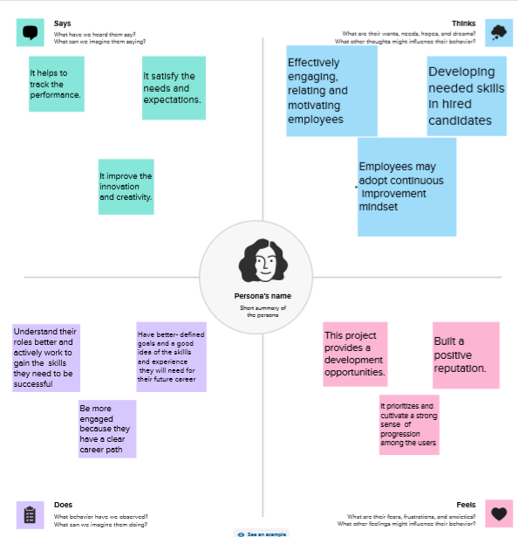

**2.2 Ideation& Brainstorming map**

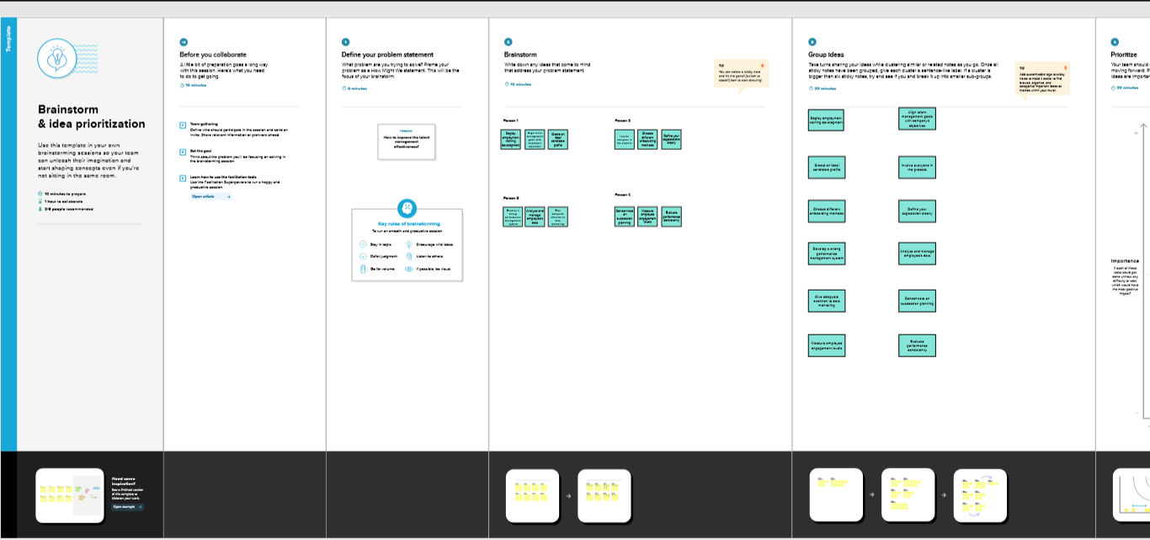

**3.DATASET**

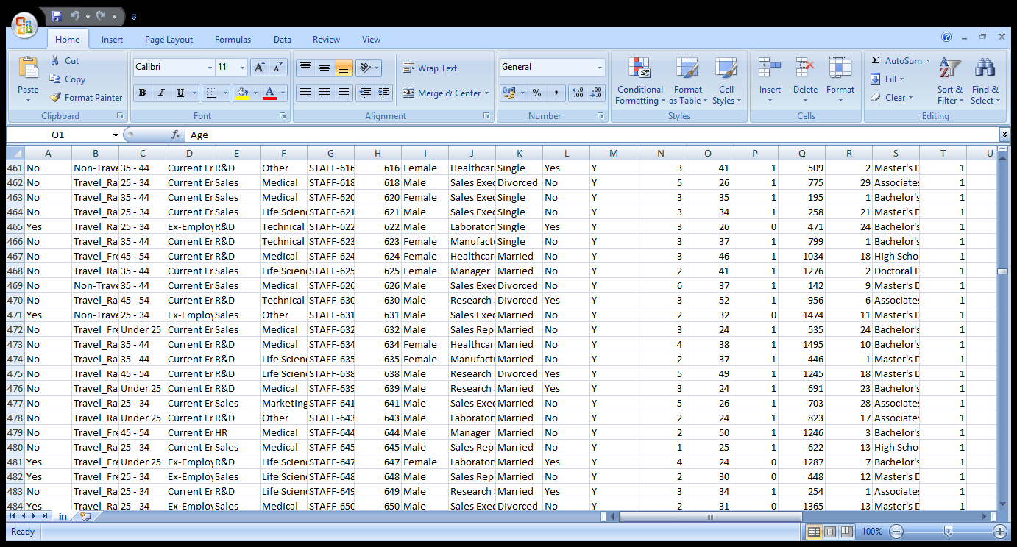

**4.VISUALIZATIONS**

**4.1 KPI**

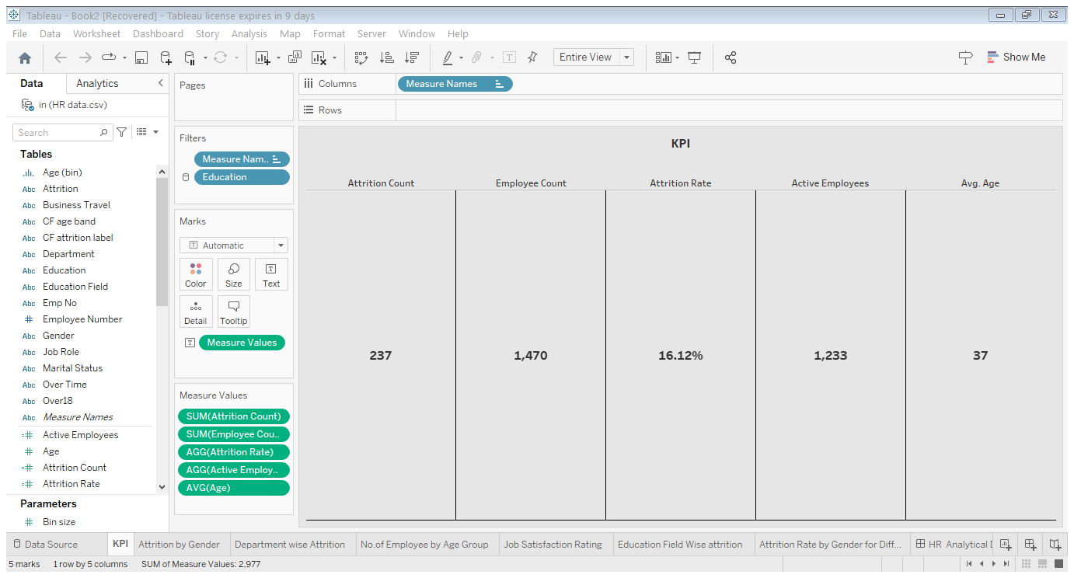**4.2 Department wise Attrition** 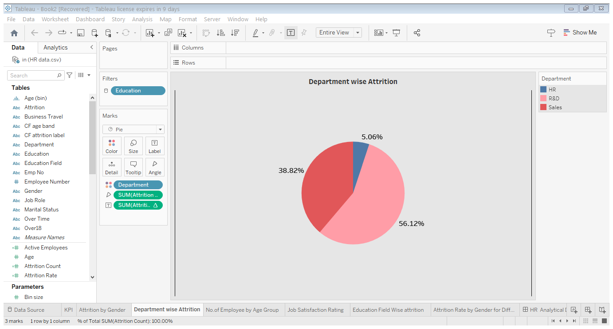

**4.3 No.of Employee by Age Group**

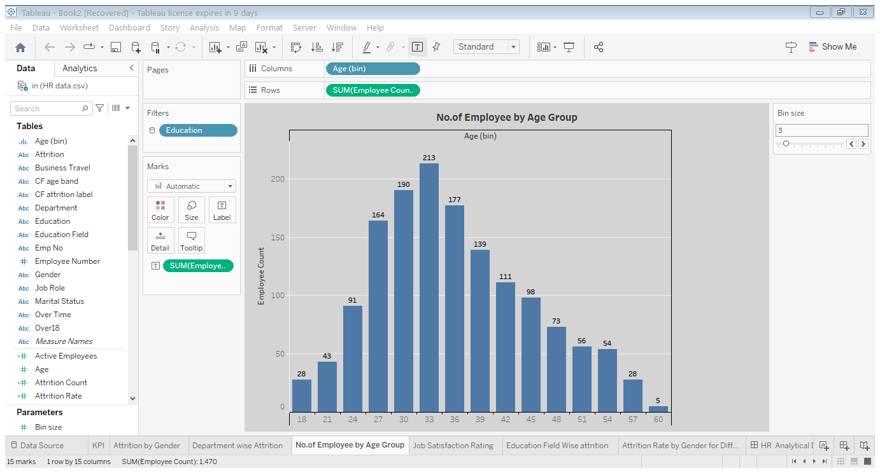

**4.4 Jop Satisfaction Rating**

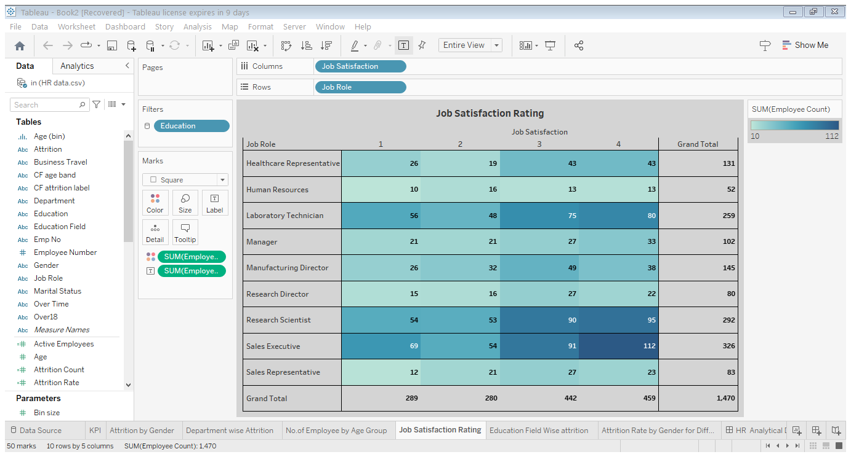

**4.5 Education Field wise Attrition**

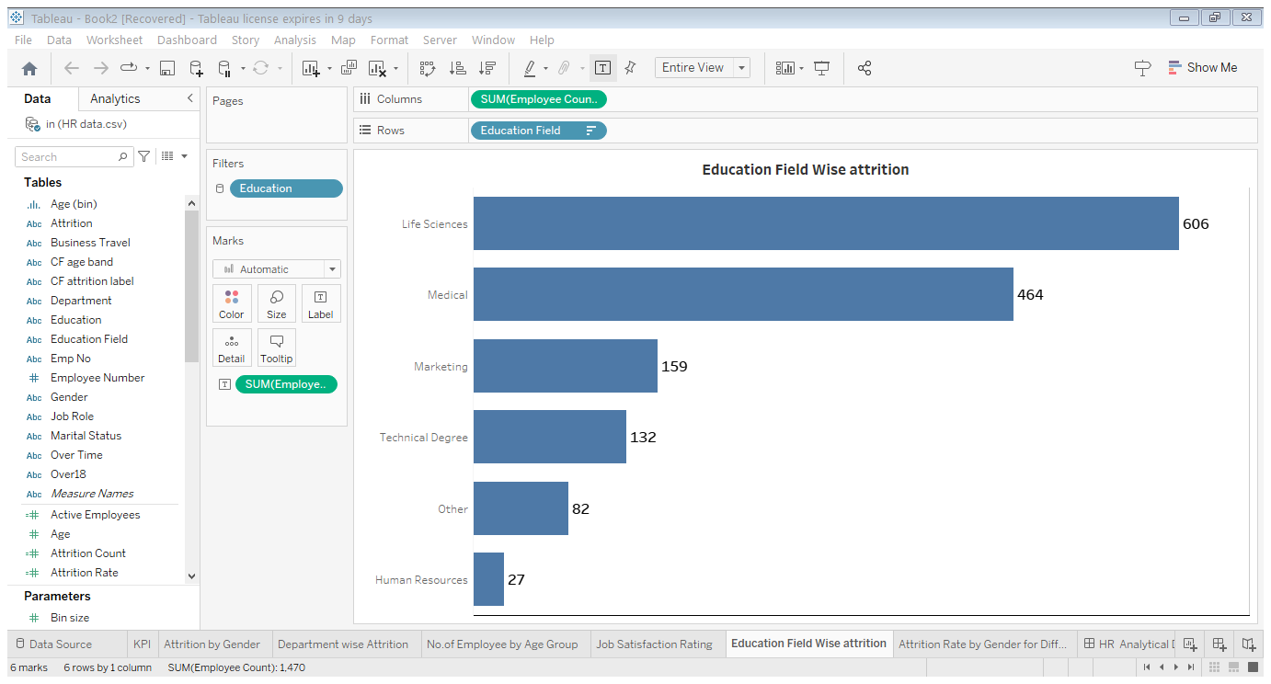

**4.6 Attrition Rate by Gender for Different Age Group**

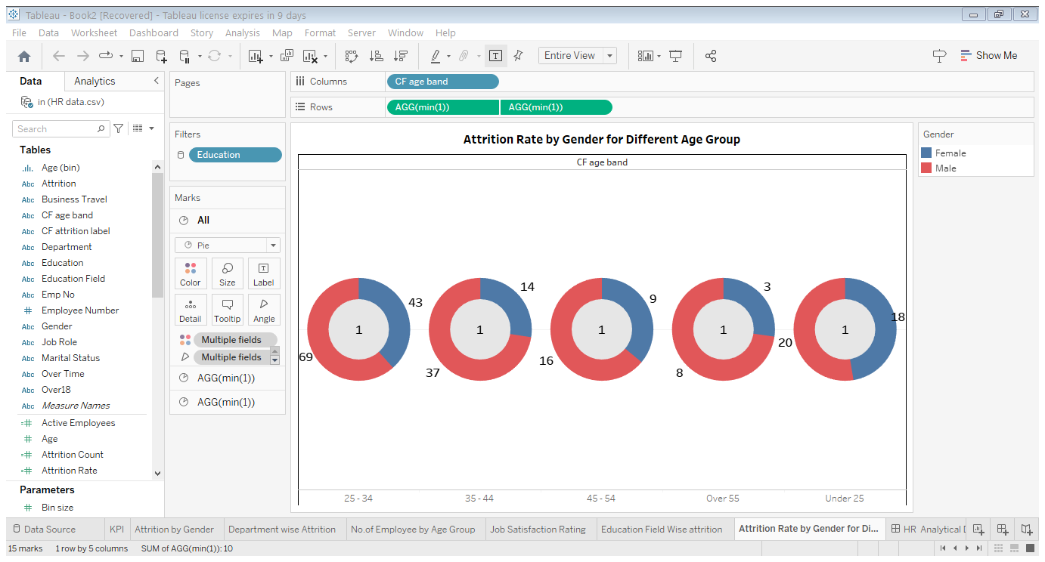

**4.7 Attrition by Gender**

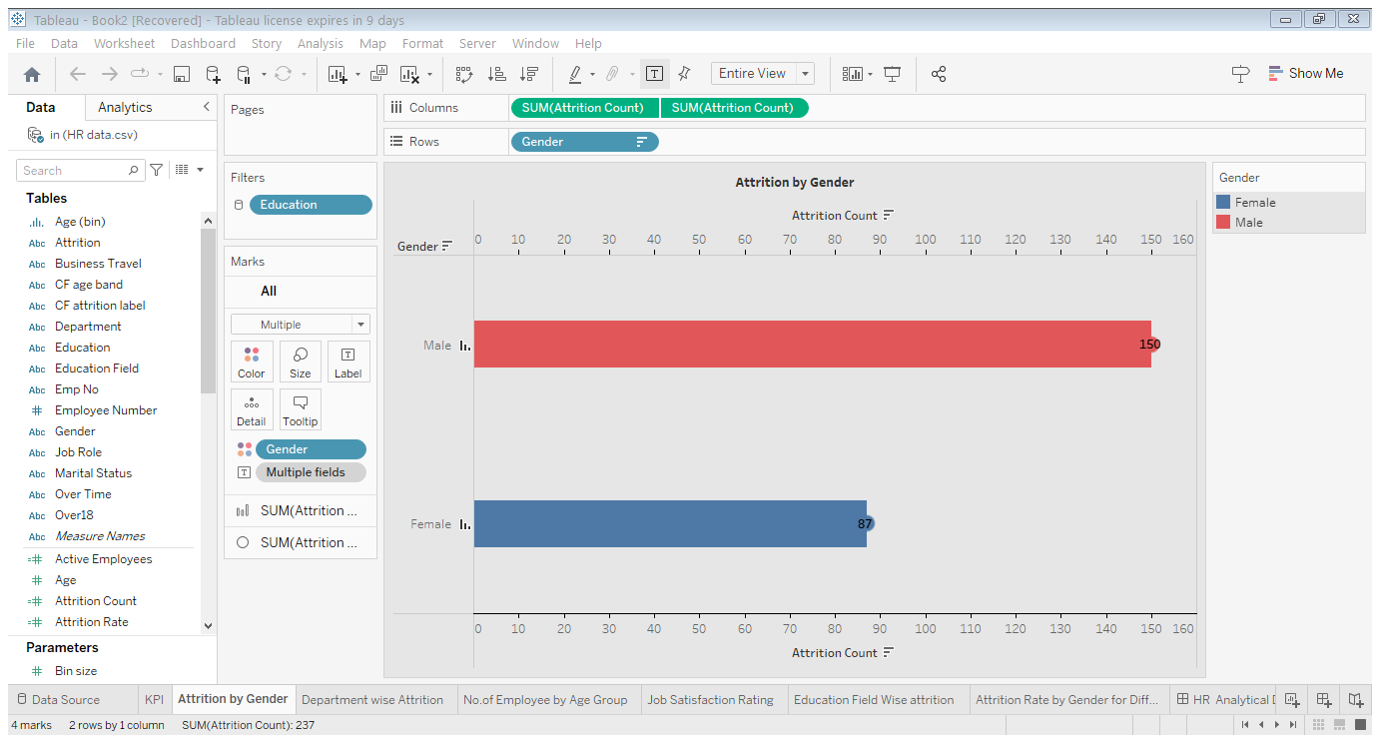

**5. RESULT**

**5.1 Dashboard**

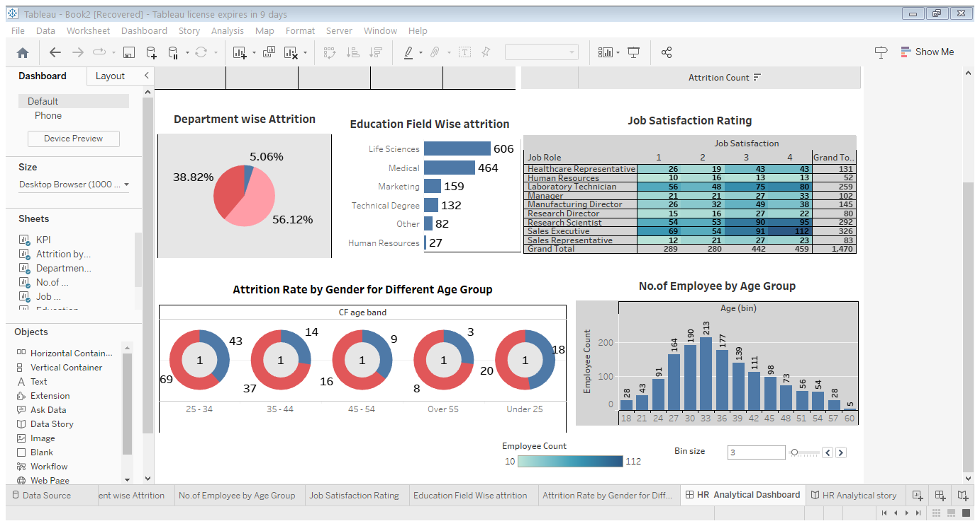

**5.2 Story**

**Story of HR Analytical**

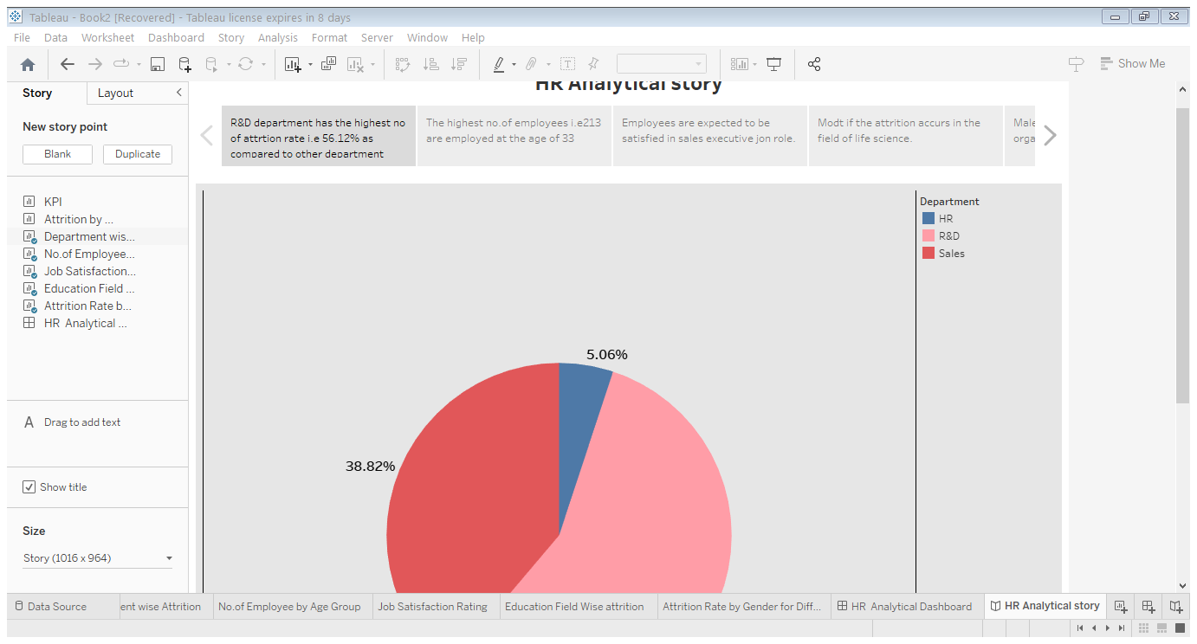

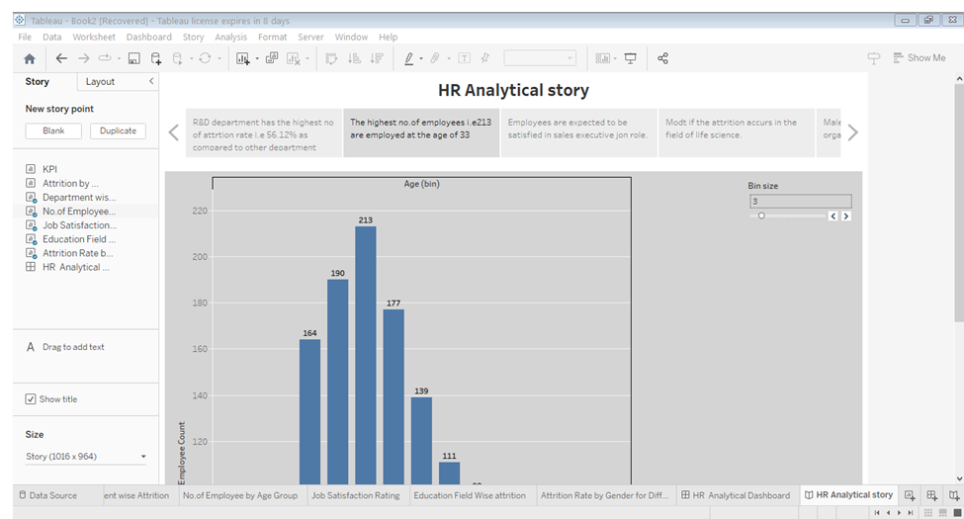

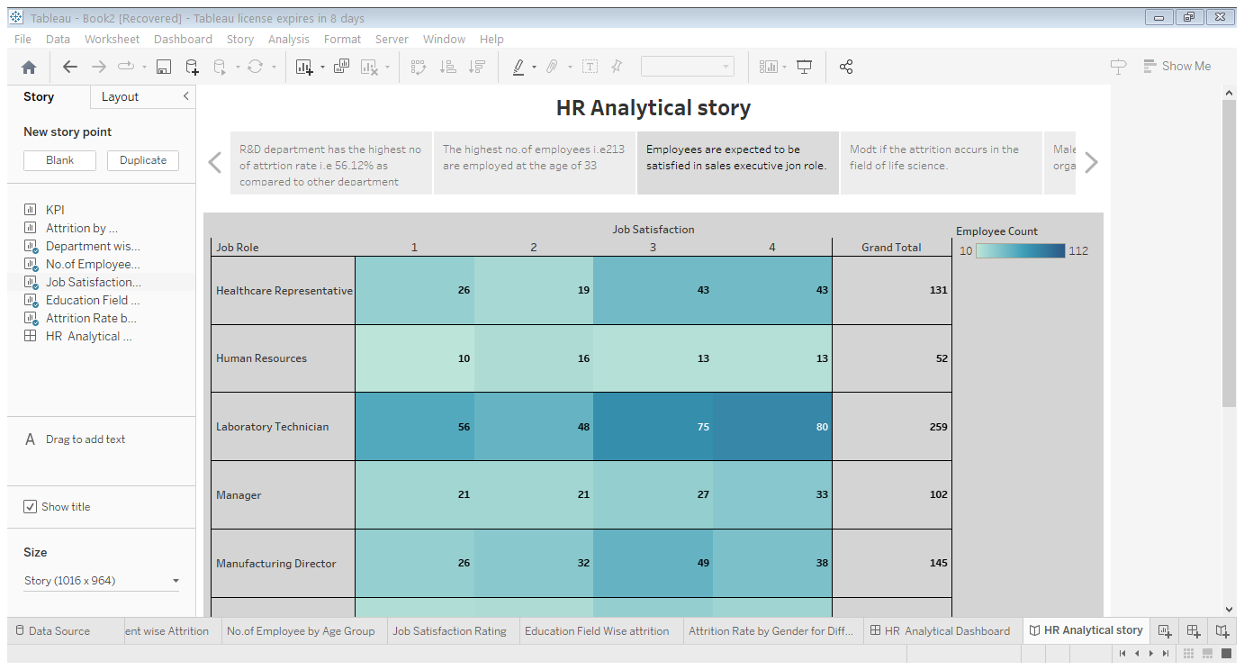

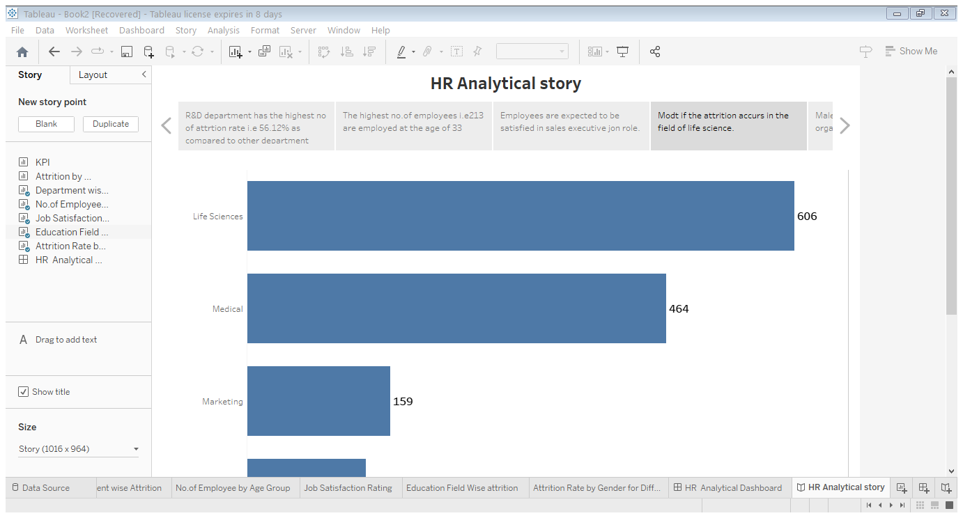

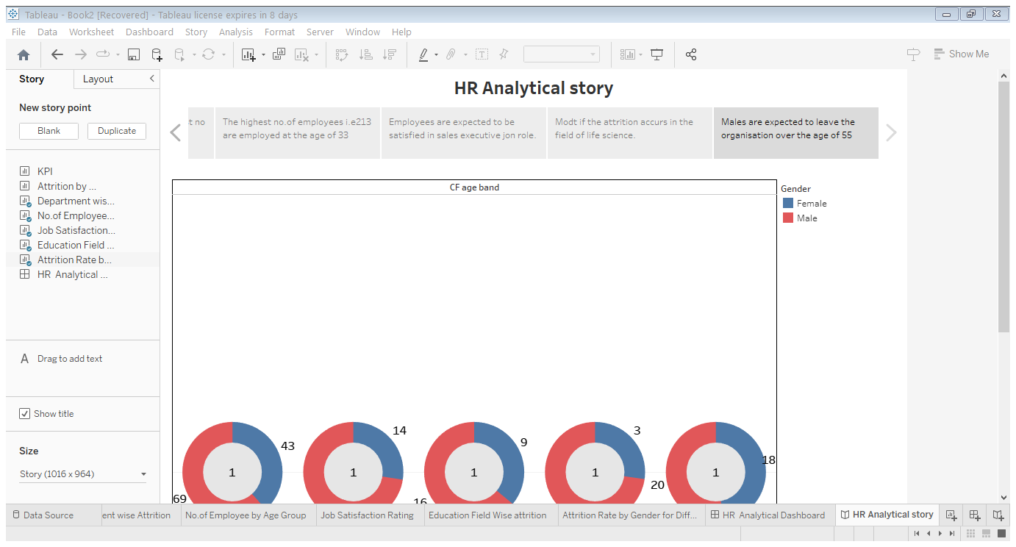

**6.WEB PAGE**

**This is the webpage that is created to demonsrate our project.**

6.1 Publication of Dashboard

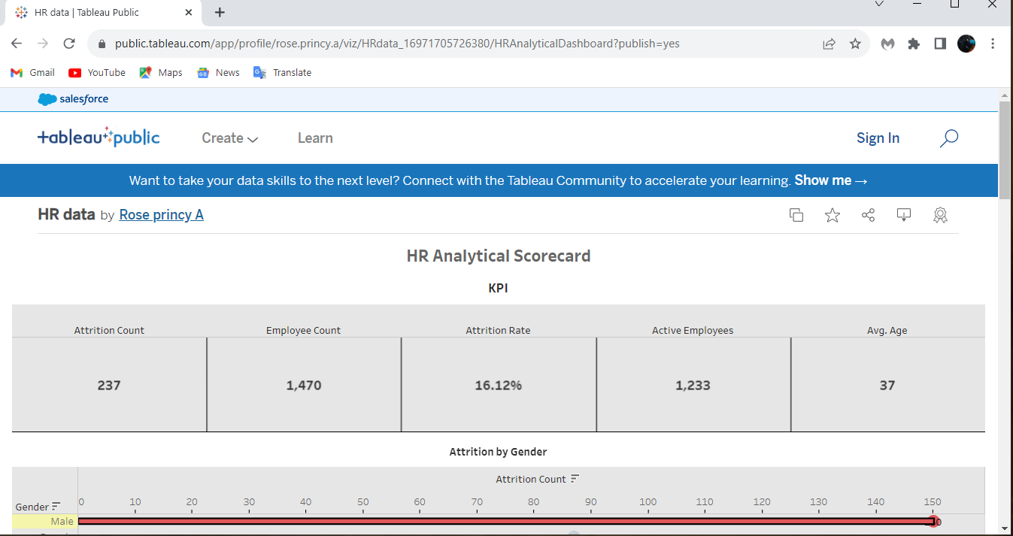

6.2 Publication of story

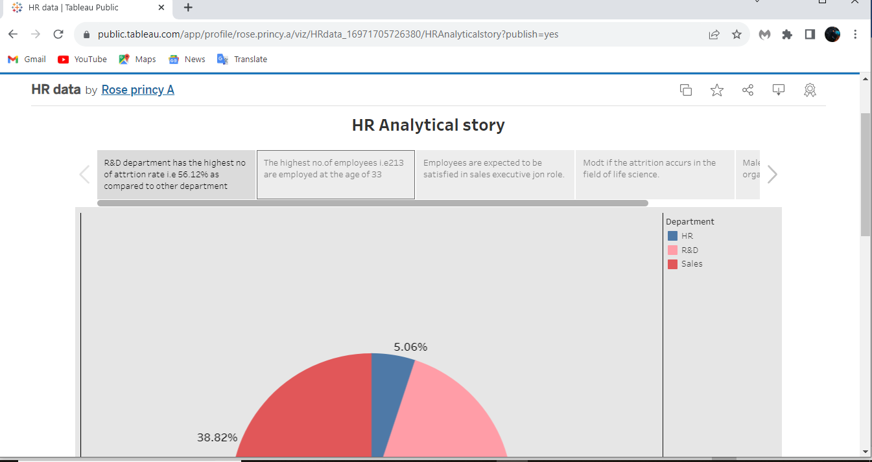

**7.ADVANTAGE AND DISADVANTAGES**

**7.1** [**Advantages of Talent Management**](https://businessesranker.com/advantages-and-disadvantages-of-talent-management/4698/#Advantages_of_Talent_Management)

[1. Improved Organizational Performance](https://businessesranker.com/advantages-and-disadvantages-of-talent-management/4698/#1_Improved_Organizational_Performance)

[2. Improved Employee Retention](https://businessesranker.com/advantages-and-disadvantages-of-talent-management/4698/#2_Improved_Employee_Retention)

[3. Competitive Edge for the company](https://businessesranker.com/advantages-and-disadvantages-of-talent-management/4698/#3_Competitive_Edge_for_the_company)

[4. Increased Employee Engagement](https://businessesranker.com/advantages-and-disadvantages-of-talent-management/4698/#4_Increased_Employee_Engagement)

[5. Reducing Recruitment Costs](https://businessesranker.com/advantages-and-disadvantages-of-talent-management/4698/#5_Reducing_Recruitment_Costs)

**7.2** [**Disadvantages of Talent Management**](https://businessesranker.com/advantages-and-disadvantages-of-talent-management/4698/#Disadvantages_of_Talent_Management)

[1. Difficulty in Implementation](https://businessesranker.com/advantages-and-disadvantages-of-talent-management/4698/#1_Difficulty_in_Implementation)

[2. Resistance to Change](https://businessesranker.com/advantages-and-disadvantages-of-talent-management/4698/#2_Resistance_to_Change)

[3. Difficulty in balancing short-term and long-term goals](https://businessesranker.com/advantages-and-disadvantages-of-talent-management/4698/#3_Difficulty_in_balancing_short-term_and_long-term_goals)

[4. Lack of Numerical Metrics](https://businessesranker.com/advantages-and-disadvantages-of-talent-management/4698/#4_Lack_of_Numerical_Metrics)

**8.APPLICATIONS**

A talent management system, or TMS, is an integrated software platform that supports core talent management processes, including recruitment, employee onboarding, performance management, learning and professional development, compensation management, and succession planning.

9. CONCLUSION

Talent management has become one of the most improvement in corporate HR and training today.Organisation know that they must have the best talent in order to succeed in hypercompetitive and increasingly complex global economy. They must manage talent in a critical resource to achieve the best possible results in long run.

The war for talentis becoming more and moreand widespread. The organization who want to acquire competitive advantage should implement appropriate strategies which bridges the gab that develops talent in organization to meet global challenges.

**10.FUTURE SCOPE**

Talent management is the full scope of HR processes to attract, onboard, develop, motivate, and retain high-performing employees. Talent management is aimed at improving business performance through practices that make employees more productive.